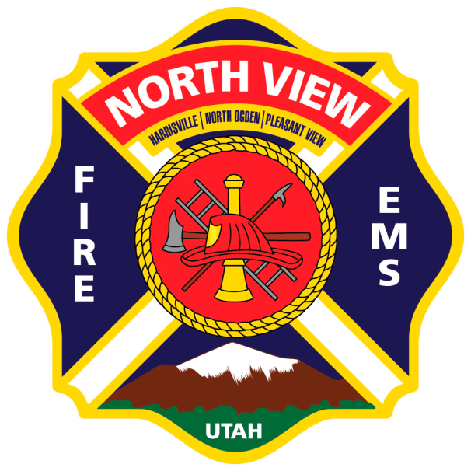

BATTERY-POWERED EXTRICATION EQUIPMENT SOLICITATION

NORTH VIEW FIRE DISTRICT
Battery-Powered Extrication Equipment
Issued: August 12, 2020

You are cordially invited to submit a proposal for a new, battery-powered, extrication spreader. The North View Fire District will be purchasing a battery-powered, extrication spreader with batteries for a price not to exceed $15,000.00. An additional Solicitation of Bids for batteries and a battery-powered, extrication cutter will be written in the future. Prospective respondents are advised to carefully read this information prior to submitting a proposal.

ALL PROPOSALS/BIDS MUST BE RECEIVED BY:
Wednesday, August 26, 2020 by 2:00 p.m.

INSTRUCTIONS TO BIDDERS

Bidders are requested to read the complete bid invitation carefully and submit their proposals in strict accordance with the requirements set forth.

Sealed bids are to be delivered to:

North View Fire District
315 E. 2550 N.
North Ogden, UT
84414

These instructions are part of your bid, and your signature on the completed proposal schedule serves as a warranty that your bid is genuine and that you have read understood and agree with all contract provisions.

Any questions please contact Deputy Chief Jeremiah Jones at (801)782-8159.

Evaluation of Bids-Award

All proposals in response to this Solicitation will be evaluated in a manner consistent with the Utah Procurement Code and the District’s Purchasing Policy. The District reserves the right to reject any or all submittals, or to waive any formality or technicality in any submittal, in the best interests of the District. This Solicitations falls within the District’s small purchase policy. As such, the District will make its selection based on the proposal criteria listed herein, including cost, but the District is not obliged to select the service provider presenting the lowest cost quotation. The North View Fire District will evaluate each bid using the objective criteria, which may include:

- Experience
- Performance ratings
- Inspection
- Testing (comfortability, ease of use, battery life, etc.) see below for additional testing clarification
- Quality
- Workmanship
- Time and manner of delivery
- References
- Cost (Not to exceed $15,000.00)
- Suitability for a particular purpose

Testing

A committee of operations personnel from the North View Fire District will be assembled to demo and grade the proposed tool(s). This will be set up after the final bidding has closed. We will make accommodations to ensure that each participant receives an equal time slot. During this time, you will be allowed to have two representatives to present your tool(s). North View Fire District or its affiliates will provide cars for demolition during this demonstration. We will practice safe distancing and mandate the use of masks whenever persons are within 6’ of each other. Proper PPE will be mandated, and a safety officer supplied. This committee will then use the grading criteria to issue a grade. This grade will be reported to the North View Fire District administration and will then be added to the other grading criteria. The final decision will then be approved by the North View Fire District Board of Trustees at the board meeting on September 21, 2020 at 5:00 p.m.

SOLICITATION NO_01-2020

DUE DATE: August 24, 2020
TIME: By 2:00 p.m.

Battery-Powered Extrication Spreader and Batteries

Sealed bids are to be delivered to:
North View Fire District; 315 East 2550 North, North Ogden, Utah 84414
I/We propose to furnish to North View Fire District meeting specifications and under the conditions set forth in accordance with
SOLICITATION No. 01-2020 at the prices bid herein.

Apparatus and Equipment Bid,
FOB North Ogden, Utah $
Delivery time required after receipt of order:________________, or _______ calendar days.
I, do solemnly swear that neither I, nor to the best of my knowledge, any member of my firm or company, have either directly or indirectly restrained free and competitive bidding on this project by entering into any agreement, participating in any collusion, or otherwise taking an action unauthorized by North View Fire District.

Signature Title

Firm Name Address

Date City/ State/ Zip

